2021 - 2022

BCANY Section official of the year

BCANY Proudly presents

this award to:
SECTION: X

OFFICIAL NAME HERE
 | Dave Archer | 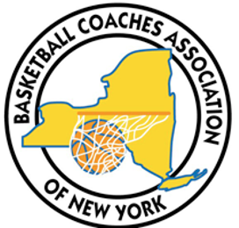 | Kurt Ehrensbeck
 | Executive Director |  | President
BASKETBALL COACHES ASSOCIATION OF NEW YORK INC.

