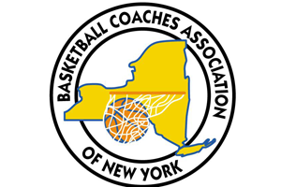
Basketball Coaches Association of New York

BCANY Team First Award
2019-20

Presented to
Player’s Name
for putting the Team First
Basketball Coaches Association of New York, Inc.
Executive Director, 524 Dickson Street, Endicott, New York 13760
www.BCANY.org
Commitment – Service - Sacrifice
Dave Archer
BCANY Executive Director
Larry Jones
BCANY President

