2019-20 Sectional Award

Name

Section - Class

Free Throw Champion

Dave Archer

BCANY Executive Director

Larry Jones

BCANY President

Basketball Coaches Association of New York, Inc.

Executive Director, 524 Dickson Street, Endicott, New York 13760

www.BCANY.org

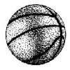

Basketball Coaches Association

of New York, Inc.