2021 - 2022

ASSISTANT COACH AWARD

BCANY Proudly presents

this award to:
NAME HERE
FOR BEING A DEDICATED ASSISTANT COACH.
 | Dave Archer | 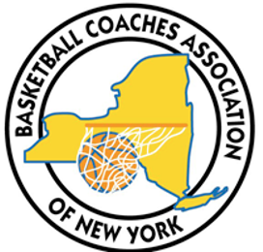 | Kurt Ehrensbeck
 | Executive Director |  | President
BASKETBALL COACHES ASSOCIATION OF NEW YORK INC.

