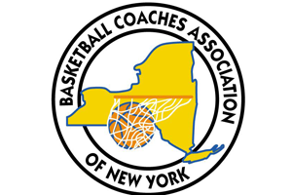
Basketball Coaches Association of New York

Presented to
Scholar Athlete Award
2019-20

Player Name
in recognition of your academic and athletic performance.
Basketball Coaches Association of New York, Inc.
Executive Director, 524 Dickson Street, Endicott, New York 13760
www.BCANY.org
Dave Archer
BCANY Executive Director
Larry Jones
BCANY President

