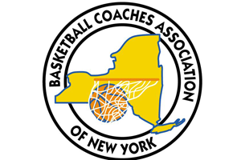

Basketball Coaches Association of New York

**BCANY Service Award**

2019-20

Presented to

**Name**

for outstanding service

Basketball Coaches Association of New York, Inc.

Executive Director, 524 Dickson Street, Endicott, New York 13760

www.BCANY.org

Dave Archer

BCANY Executive Director

Larry Jones

BCANY President