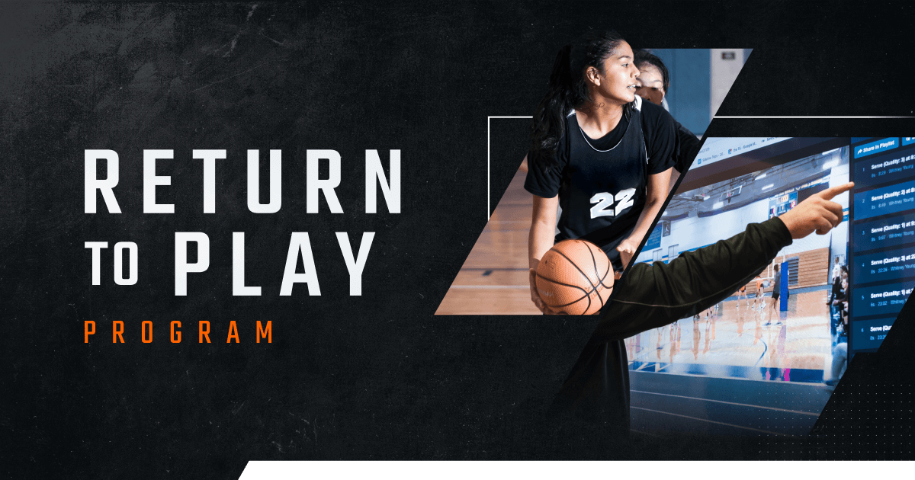

Be ready for anything.

We don’t know what this basketball season will have in store, but Hudl has resources to help you prepare. From dealing with no-fans-in-stands restrictions to navigating remote recruiting, get all the info you need to navigate any challenges posed by the coronavirus outbreak.

To ensure that tight budgets don’t stand in between you and the tools you trust and rely on to succeed, Hudl has rolled out the Return to Play Program. With a two-year contract, your school can upgrade to an athletic department package at your current subscription rate for year one.

Talk to your AD to see if the Return to Play Program is right for your school.

Get More Info

