2021 - 2022

SECTION X SERVICE AWARD

this award is proudly

presented to:
NAME HERE
FOR SERVICE TO SCHOLASTIC BASKETBALL.
 | Dave Archer | 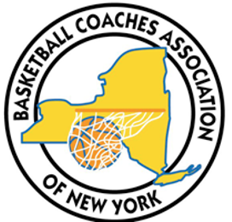 | Kurt Ehrensbeck
 | Executive Director |  | President
BASKETBALL COACHES ASSOCIATION OF NEW YORK INC.

